# **5.1 Introduction**

Since the approach to the development project is discussed this chapter focuses on explain the data gathering and analysis of that data to produce a set of user stories. User stories were converted into the functional requirements and UML techniques have being used to represent the system in different technical and non-technical perspectives. At the end of this chapter some of the important user interfaces are also shown.

# **5.2 Data Gathering & Analysis**

Data gathering and analyzing the data in order to identify the exact requirement is a key factor in making a project success. Limited number of data collection methodologies were used to keep it simple. Main data source was from interviews and document reviews and field visits also help to gain rich knowledge in the domain.

The easiest method to get close to the staff and their information was the interview method. The staff was more conversant in the local language of Sinhala. They were much more comfortable with the interviews. The interviews were conducted amongst some senior managers as well. They came up with good suggestions.

Observation is another method which was used to gather data in the initial stages. This is method which performs an informal assessment technique which involves specifying, counting, and recording MVCS procedure. The observation is an interesting part of the research as to the practical experience. The agonizing part was to wait until an accident or breakdown occurred. The biggest advantage of an observation tour is that you get a picture of the whole spectrum of the system. We see for ourselves that the claiming staff members are actually quite competent and pretty quit in their work. It just seems so that they want to finish off the evaluation as soon as possible. The important factor to consider here is that it shows us on what other areas do they might be vulnerable to make an error.

Documents reviews were very much helpful in designing the database for the new solution. There were several forms to be studies and finally design a compatible database design to hold all the necessary data. There were issues with some of the form kind since they were not able to provide it for studying purposes since they are confidential.

Since the agile methodology was used there was no pre planning like in traditional software development cycle. After few initial meetings few user stories were created using the knowledge and confirmed them with the users. After that the development was started and as they were completed feedback was taken and new requirements and improvements were identified. Similar cycle was maintained until the end of the project to keep the users also updated.

After the initial data gathering and analysis user stories are created and according to them system is designed according to various technical perspectives. The MVCS systems design is presented gradually by stating the overall system architecture. Then the rest of the architectural designs would be described independently. The software design, the module architecture, the database, web application, tab application and the interface design would all be dealt with in detail. This chapter would be the place where all the analysis and research comes in to usage. The theory will be tested in to practice and the limitations and ideas would be spelt out at each level of the design

5.3 Use Cases for the new solution

This diagram show how the users interact with the solution in respect the components of the solution which are web application, tab application and mobile application.



The following figure depicts the use case diagram for web application component of the solution.

Note : Admins also have to login to the system in order to interact with other modules.

Next use case diagrams illustrate the tab application component of the solution and the smartphone application which clients can use.





Class Diagram for the new solution

Class diagram expresses the various kinds of system objects and different types of relationships exist among those system objects. System objects and relationships that are involved in the proposed system are represented in the following diagram



Sequence diagrams for new solution

Following diagrams represents how the processes in the new system operate with one another and in what order.

Following diagram illustrates sequence diagram for accessing a module in web application.



Following diagram illustrates sequence diagram for accessing a module in tab application.



Following diagram illustrates sequence diagram for accessing a module in smartphone application.



# **5.3 Overall System Architecture**

Architectural design defines the overall structure and the connections in between components of the solution before moving on to the detail design or the low level design which includes the design of specific components details. The architectural design is given according to the three-tier-architecture where overall design is spilt in to three layers of Client Tier, Application Tier and Data Tier. The overall system architectural design for the proposed system is as follows.



As the above given design illustrates company office web application is build and hosted in a web server along with a central database. A web service is attached to the web application in order for agent tab application and client mobile app to connect with the company web application. Web service is accessible through internet or data communication media.

# 5.3.1Application Layer

The company logics and processes of the system will be executed at this layer in order to achieve the expected objectives of the system and can be named as the heart of the overall system. This layer will interact between application layer where the interfaces are running and data layer where the information is stored. Data gathered by user inputs or by other processes will be manipulated according to the predefined operational instructions at this layer. The client, incident and vehicle information will be applied in the application for the user to access and input data. The main components of this layer will be the web application for ground staff and the web service hosted for the communication of tab application and phone application.

4.1.2Data Layer

Data layer manage the data storage operations of the overall system where the database management applications are running. A central database containing the information about policies, claims, vehicles, spare parts and employees will be stored in several tables in the database in order to improve the efficiency. Tab application and the mobile application will communicate with the database through web service while web application will directly communicate with the database.

4.1.3 Presentation Layer

Presentation layer is responsible of control interactions with users by monitoring interfaces to current requested information and retrieve the inputs delivered by the user. Information gathered by this layer will be provided to the application layer in order to manipulate according to the given instructions. Main system components in this layer are tab application and the mobile application. Data added through the apps will be communicated to the company web application through the web service.

4.2 Software Architecture

Software architecture was based on modularized approach where the software is divided into parts. Each module is assigned to execute one or more tasks of the overall system in order to achieve the ultimate objectives expected. The software architecture is details in the following illustration and we see the different layers of the total system.

The solution has three major user interacting components namely web application, tab application and the mobile application. Operating staffs web application will be the major data source for the database. They will be in charge with registering policies, updating vehicle details and process and also administrative purposes also. Tab application will be used to issue a claim to the client and claiming agent’s needs to log into tab application to conduct the claiming process. Client mobile application is used to inform the office about the accident via web to the operating staff with its GPS coordinates. These 3 components are connected by the web service to the web application and to the database.

4.4 Module Architecture

Main modules and sub-modules

* Online claim management system (Web application)
  + Insurance policy module
  + Customer details module
  + Vehicle detail management module
  + Spare parts module
  + Garage services module
  + Tow truck services module
  + Client requests module
  + Employees and user account management module
  + Claim review module
  + Vehicle categories module
  + Spare part categories module
  + Manufacturers module
* Web service module
  + Connect tab application and mobile application to the web application component.
* Authentication module
  + Authentication to the web application
  + Authentication to the Tab application
* Tab application component
  + Policy information module
  + Claim history information
  + Spare part details module
  + Claim assessment module
  + Image upload module
  + Garage services module
  + Tow truck services module
* Mobile application component
  + Inform accident with GPS coordinates

In below some of the most important modules are explained at a high level using graphical representations.

Login module



Every type of user needs a valid account to login to the respective application. Operating staff will be given access to login to the web application while the claim agents will be given access to the tab application. Since the web application is hosted in the cloud, once the user enter their credentials data has to pass through the network and confirm it from the database and provide the confirmation back to the user through the network. Web application will communicate with database directly via database module interface while tab application will communicate through the web service and database interface module.

Online claim management system (Web application)



Once the user login to the web application user can choose a module to interact with, which also will be filtered according to user type. As shown in the diagram user can chose a module and o to that modules particular interface. From that interface user can coordinate any possible action such as add a record. Then via the network data will be sent to the cloud database. Similarly user can go back and choose a task to perform and deal with it accordingly.

Tab application component



Similarly as the web application once the user login to the web application user can choose a module to interact with. As shown in the diagram user can chose a module and o to that modules particular interface. From that interface user can coordinate any possible action such as calming procedure. When user submit data from the tab device they will be communicated to the web service through the network and web service will handle the communication with the company database.

Mobile application component



Mobile application component is a very simple component which requires no login from the customer. Customer can open the app and enter policy number and request for a claim agent. Data will be communicated to the web service via the network and web service will handle the communication with the company database.

**4.5 Database Design**

The database was a very important in developing the solution of TBMVCS. Since we are giving a lot of assurance of data and sorting and calculation of data the database should also have a good foolproof design. As the database technologies, SQL server 2012 was used because it is easy and quick to respond for the solution and provide easy interfaces for creating tables and testing purposes. Stored procedure were used for querying in order to make the code reusable.

EER Diagram

Following figure conceptual database diagram for the solution



Database Relationship diagram

The diagram shown in the next page indicated the relationship among tables in the database.

Given bellows are some of the tables

|  |  |  |
| --- | --- | --- |
| Customer Table | | |
| Attribute | **Data Type** | **Length** |
| CustomerId | Int | - |
| Salutation | nvarchar | 10 |
| Initials | nvarchar | 20 |
| Firstname | nvarchar | 50 |
| Lastname | nvarchar | 50 |
| AddressNo | nvarchar | 10 |
| Street | nvarchar | 50 |
| City | nvarchar | 50 |
| NIC | nvarchar | 25 |
| Home | nvarchar | 20 |
| Office | nvarchar | 20 |
| Mobile | nvarchar | 20 |
| Email | nvarchar | 100 |
| Bank | nvarchar | 50 |
| Branch | nvarchar | 50 |
| AccountNo | nvarchar | 25 |

It is important that the customer is identified by the database and that the agent does not have to depend on the third party at the scene to give the necessary customer details. The customer information is entered in this relation. The attributes can be the customer ID, the customer name, his personal details, his contact information etc. the data type and the length of such data will also be entered in the customer relation

|  |  |  |
| --- | --- | --- |
| Claim Table | | |
| Attribute | **Data Type** | **Length** |
| Claimid | Int | - |
| Location | nvarchar | 50 |
| Reason | nvarchar | 50 |
| Knockedon | nvarchar | 50 |
| Thirdpartydeatilid | Int | - |
| Driverid | Int | - |
| Paymentid | Int | - |
| Isdriverowner | nvarchar | 10 |
| Vehicleusage | nvarchar | 50 |
| Rentcompany | nvarchar | 50 |
| Images | varbinary | Max |
| Rentamount | Float | - |
| Createdtime | DateTime | - |
| Empid | Int | - |

One of the key feature is to assess the claim form the tab application. Therefore this is one of the most important table in the database where we store all the claim details.

|  |  |  |
| --- | --- | --- |
| Customer Vehicle Policy Table | | |
| Attribute | **Data Type** | **Length** |
| Policy_ID | Int | - |
| Vehicle_ID | Int | - |
| Type | nvarchar | 20 |
| Commenceon | nvarchar | 15 |
| Natural_disaster | nvarchar | 20 |
| Vandalism | nvarchar | 50 |
| Tercover | nvarchar | 50 |
| Currentdamages | nvarchar | Max |
| Driver_compensation | nvarchar | 10 |
| Passenger_compensation | nvarchar | 50 |
| Towing_charges | nvarchar | 10 |
| Air_bag_cover | nvarchar | 10 |
| Strikes_riots_cover | nvarchar | 10 |

Another important table which is used to store policy details of each client. This will have relationship with customer and vehicle table mainly.

4.4 Interface Design

The user friendly interface designs for the developing system are shown below.

Tab application

Login screen

Claim agent need to be logged on to the application first. In that case, user needs to have a valid username and password given by the admin of the system. When submitting the username and password database checks the validity of entered username and password. Then it checks the user levels and provides the window according to the user type.

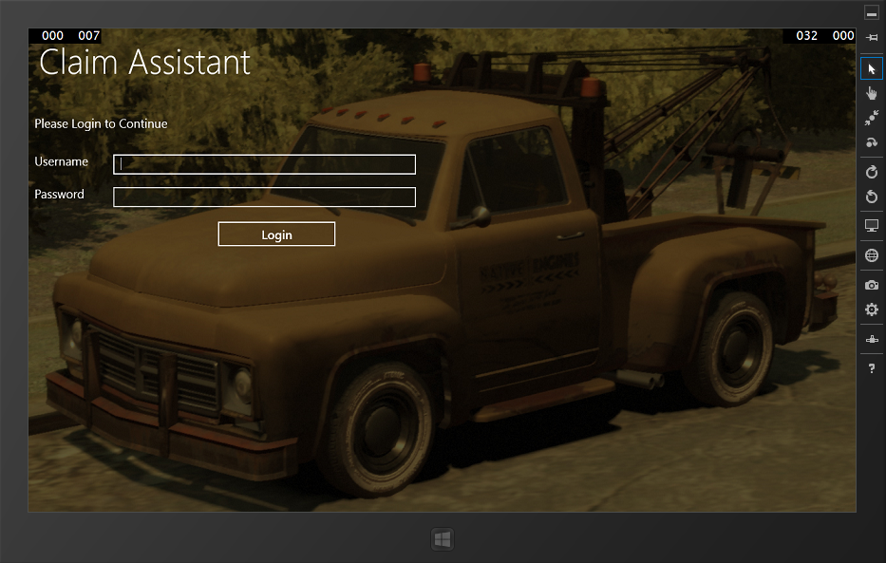

Main Menu

After a successful login this will be the land on interface. From here user can select the module which he may want to interact with.

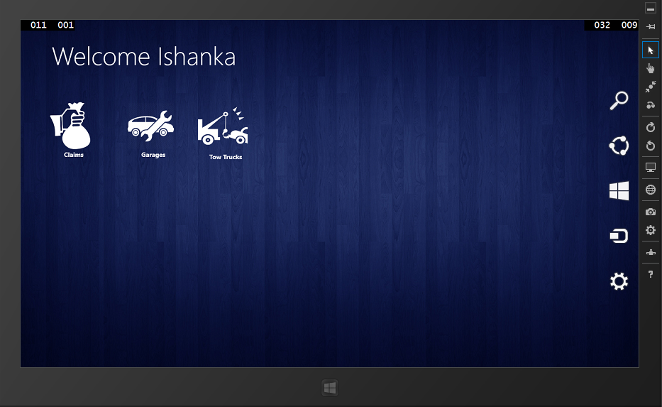

Policy Information

This is the landing page for selecting claims from the main menu. In here claim agent will enter the policy Id of a client to get his policy details. After getting information agent have to click claim button to start the assessment.

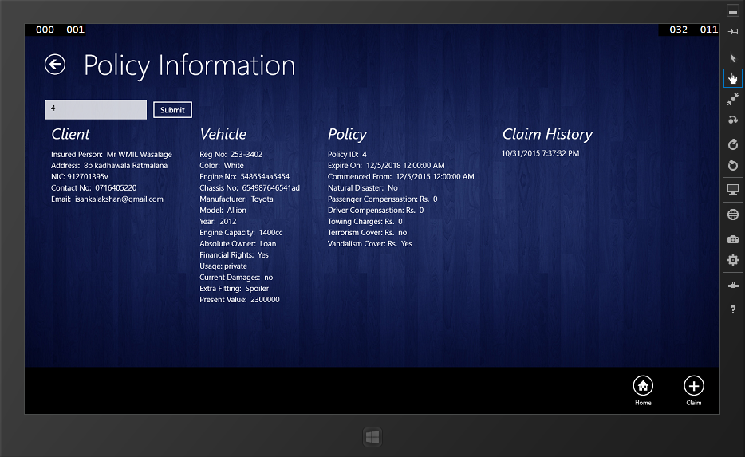

Claim Forms

After getting the policy information claim agent can start the claiming procedure by filling the series of forms in the tab application.

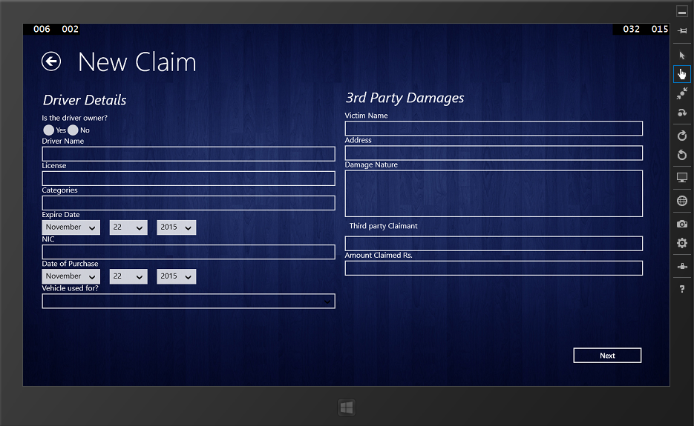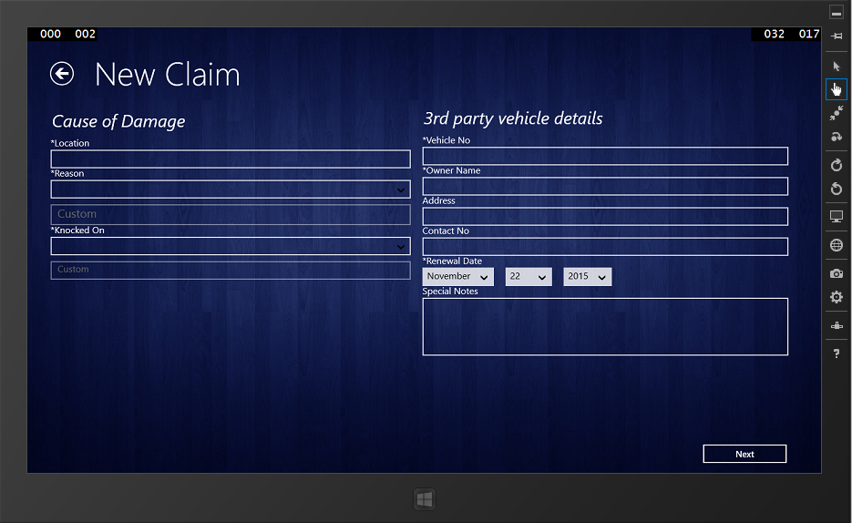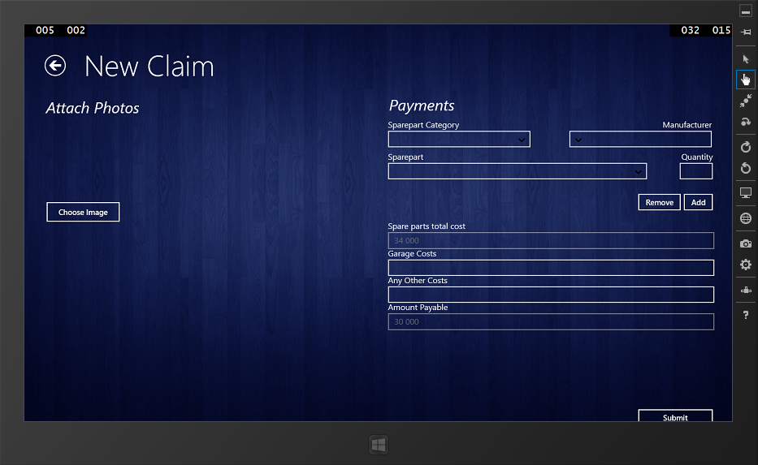

Success Screen

On the successful submit of a claim following screen will be displayed,

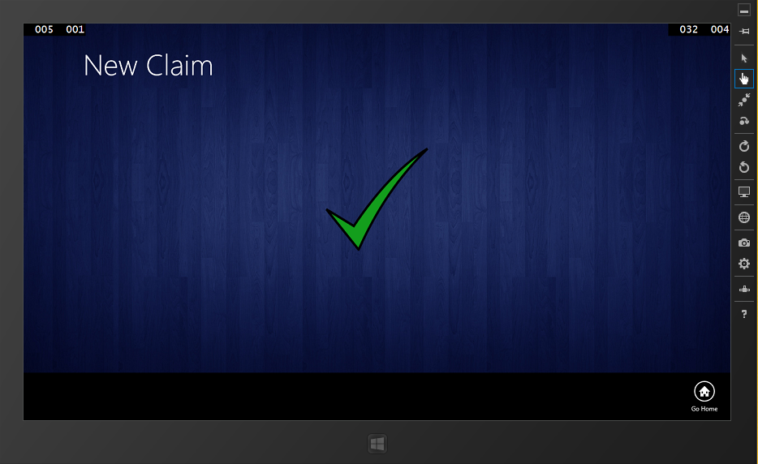

Garage Services

Following interface is used to display garage services available to the claim agent. Agent can search garages using the location.

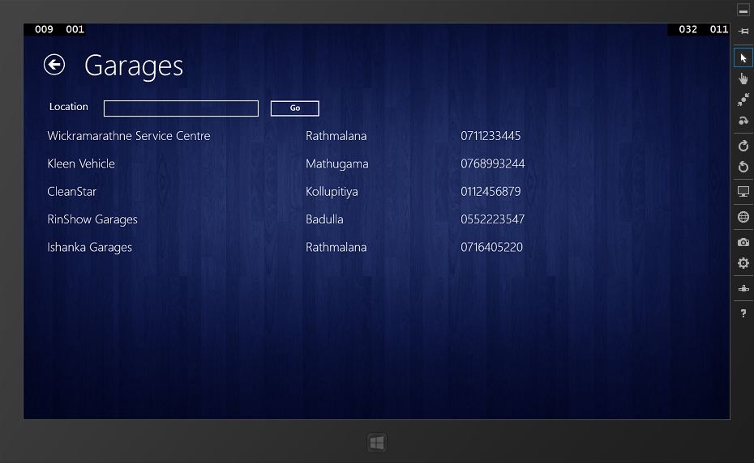

Tow Truck Services

Following interface is used to display tow truck services available to the claim agent. Agent can search garages using the location.

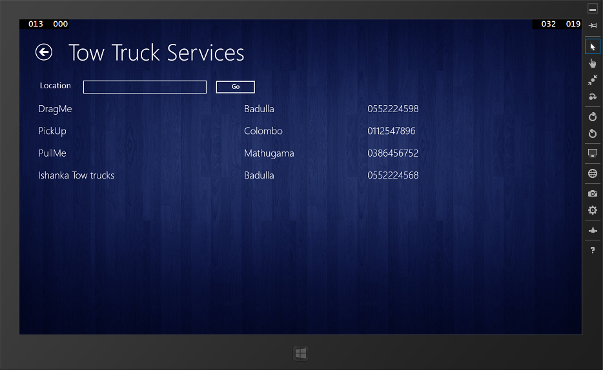

Smartphone Application

This will be the landing page when application is launched. Client will be able to enter the policy id and report it to the central system.

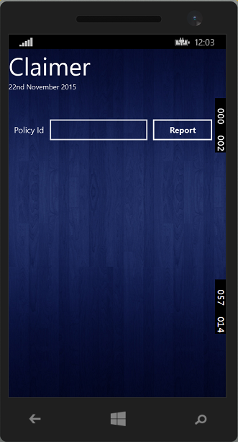

Web application

Login Interface

Users need to be logged on to the application first. In that case, user needs to have a valid username and password given by the admin of the system. When submitting the username and password database checks the validity of entered username and password. Then it checks the user levels and provides the window according to the user type.

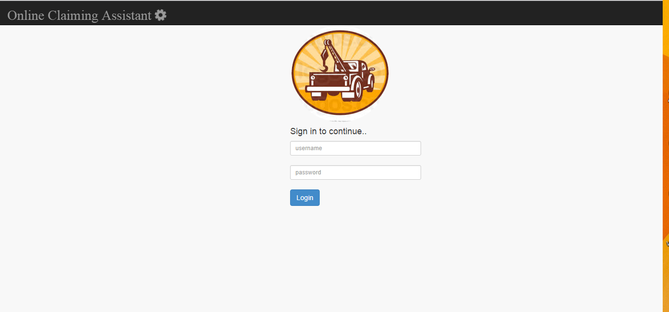

Home Interface

This will be the landing page upon a successful login to the online claim assistant system.

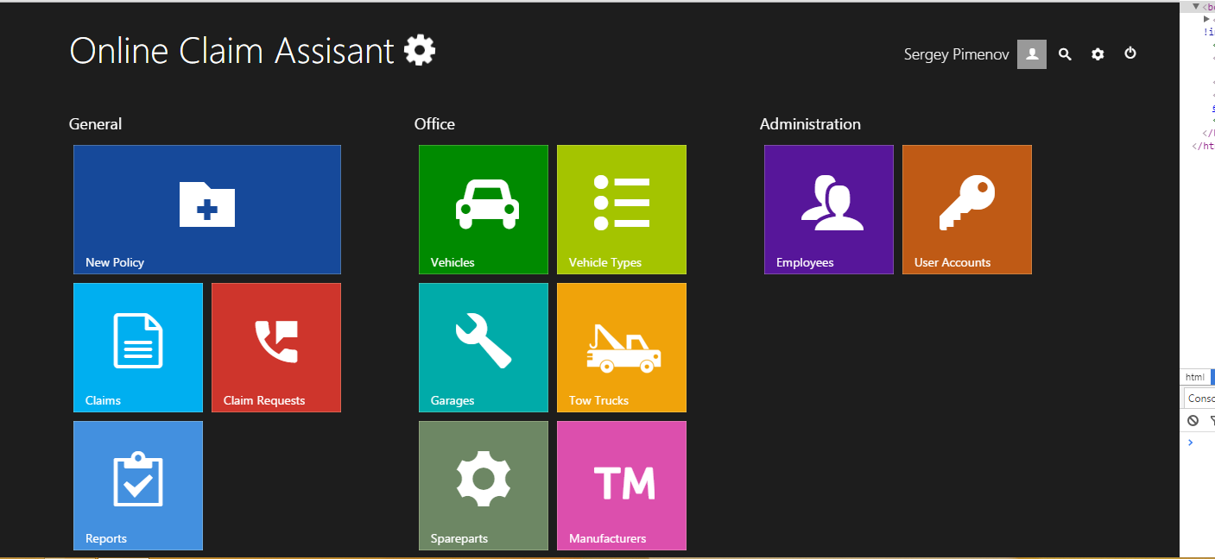

Spare part Module Interface

Following figure is a sample screen for a module screen. Shown screen is the spare parts modules interface. Other interfaces are shown in the appendix.

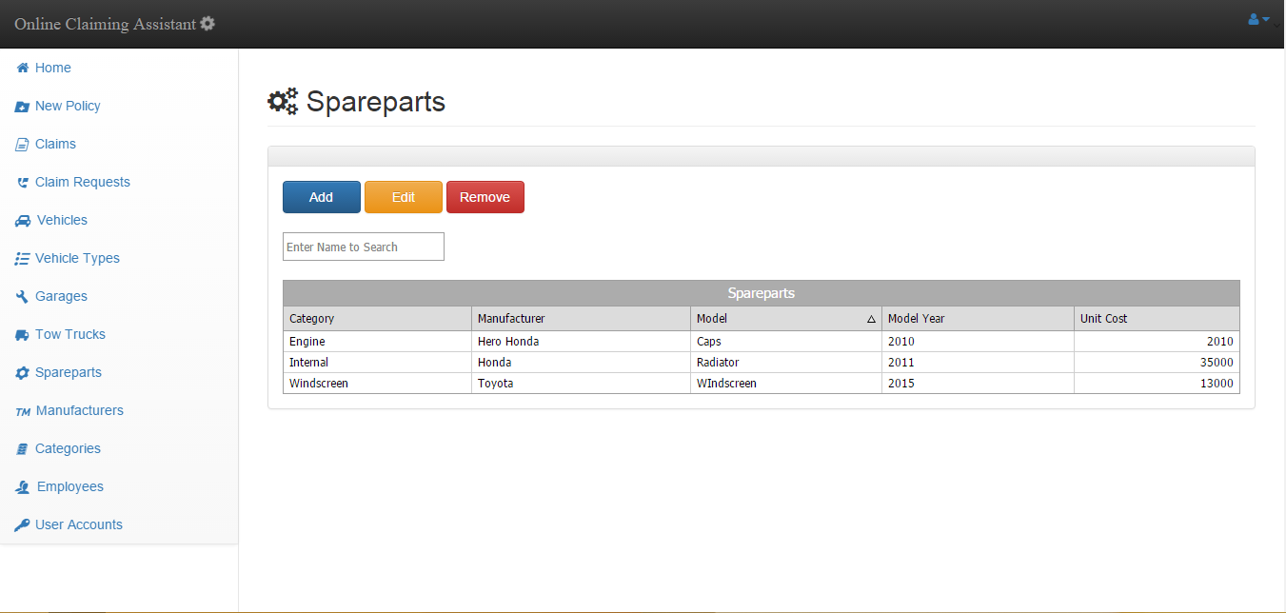

Data adding form

When user need to add new records to the database, the following shown pop up modal will be used.

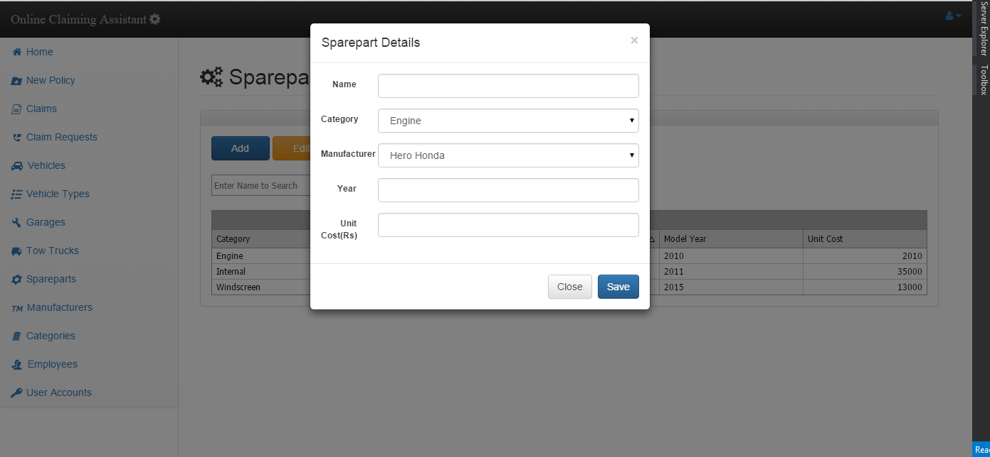

Other interfaces are attached in the appendix.

Summary

In this chapter we started with data gathering and analysis then created an outlook to the design of the MVCS system. We went through the total system architecture and the software design to find out how this system runs. Then we have discusses how the system is broken down to modules and sub modules and what these module do. While discussing the modules we have briefly gone through all the actors participating in the implementation and the process of the system and what they have to do to keep the system running. Then we spoke of the database design on general terms and the interface screen shots were given later. With this chapter anyone could have a general feeling of what the system is or what the system is going to be.